**VIVAAN MITTAL**

**CSE-3C**

**G1**

**2K20CSUN01124**

**Pt-2**

**Q1. Create Following Table: -**

**course(cid,cname,c_pre,fid)**

**faculty(fid,fname,fphone_no,salary)**

**department(did,dname,dloc,cid,fid)**

**Solution: -**

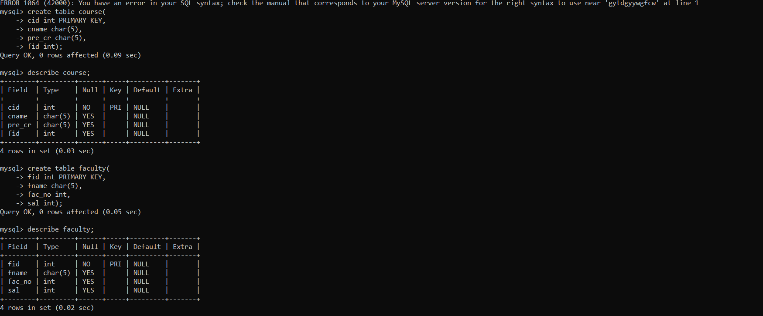

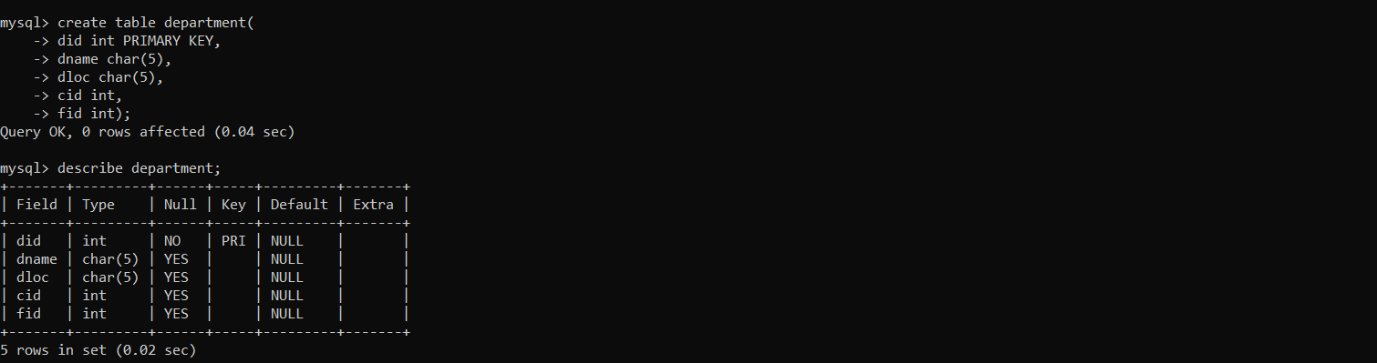

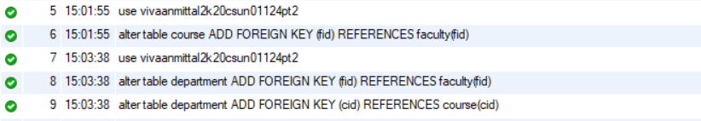

**Q2. Insert 5 Row**

**Solution: -**

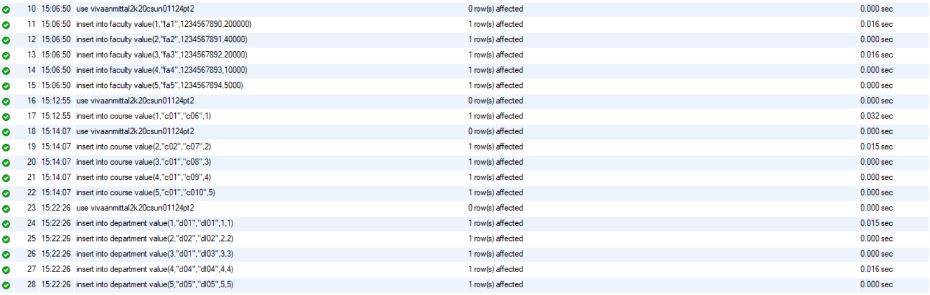

**Q3.**

**1)display the name of facalty sal>20000**

**2)cal the total no of sal for the facalty teaching in dept cse**

**3)display the loc and dept name for course id 1**

**Solution: -**

